

**Adigrat University**

**College Of Engineering and technology**

**Department Of Software Engineering**

**Project Proposal On**

**ONLINE EMPLOYEE AND EMPLOYER INTERCONNECTION WEBSITE**

A PROJECT PROPOSAL SUBMITTED TO THE DEPARTMENT OF SOFTWARE ENGINEERING OF ADIGRAT UNIVERSITY IN PARTIAL FULFILMENT OF THE REQUIREMENTS FOR THE DEGREE OF BACHELOR OF SCIENCE IN SOFTWARE Engineering.

**MEMBERS OF THE GROUP**

**NAME ID-NUMBER**

1. **HAFTAY DESTA RET/10473/11**
2. **GUESH GOITOM RET/11771/11**
3. **HIRUT TESFAY RET/14555/11**
4. **LIDAY ERMIASE RET/14444/11**
5. **HAYAT TUEM RET/06456/10**
6. **G/TSADIK BRHANU RET/10585/11**

**Advisors: Ins. Equbay G. (MSc)**

**Adigrat, Ethiopia, January, 2016E.C**

**Executive Summary**

**Project Title:  ONLINE EMPLOYEE and EMPLOYER INTERCONNECTION WEBSITE**

The "Online Employee and Employer Interconnection" research proposal aims to develop a user-friendly and efficient online platform that overcomes the limitations of manual and face-to-face employment processes.

The proposed website will facilitate job seekers in finding suitable employment opportunities and enable employers to efficiently screen and select qualified candidates. By transitioning to a digital platform, the project seeks to enhance the overall employment experience, improve access to information, and streamline communication between job seekers and employers.

The key objectives of the research proposal include creating a user-centric interface, incorporating advanced search and filtering options, implementing resume uploading and profile enhancement features and reminders.

The proposed system design and architecture will include intuitive user interfaces, a comprehensive database, user registration and authentication mechanisms, job search and filtering capabilities, job posting and management modules, resume upload functionality, efficient communication features, and an admin panel for system management.

The significance of this research proposal lies in the potential to enhance efficiency, expand employment opportunities, improve user experience, and contribute to economic growth.

In conclusion, the "Online Employee and Employer Interconnection" research proposal aims to overcome the limitations of manual and face-to-face employment processes by developing an intuitive and efficient online platform. This proposal holds significant potential to transform the job search and hiring process, providing a valuable solution for both job seekers and employers.

T**able Of Contents**

1. Introduction: 1

1.1 Background: 1

2. Statement Of The Problem. 1

2.1. Time Consuming 2

2.2. Not Cost Effective 2

2.3. Error Prone 2

2.4. Limited Geographical Area 2

2.5. More Work Load Of The Employment Agencies: 2

3. Objective Of The Project 2

3.1. General Objective 2

3.2. Specific Objectives 3

4. Scope Of The Project 3

5. Limitations Of The Project 4

5.1 The Limitations Of The Project: 4

6. Significance Of The Project 4

7. Beneficiaries Of The Project 5

8. Literature Review 6

9. Data Collection Tools And Methodology 7

9.1 Primary Data Collection: 7

9.2 Secondary Data Collection: 8

9.3 Project Methodology: Agile Methodology 8

10. Existing Systems 9

11. Proposed System Design And Architecture 10

12. Functional Requirements 11

12.1 Employer: 11

12.2 Employee (Job Seeker): 11

12.3 Admin: 11

13. Non-Functional Requirements 11

14. Hardware & Software Tools Requirements 12

14.1 The Hardware Tools Required Are: 12

14.2 The Software Tools: 12

15. Budget 13

16. Time Schedule 14

17. Conclusion And Recommendation 15

17.1 Conclusion: 15

17.2 Recommendation: 15

18. References: 15

19. Annex 16

**List of Table:**

Table 1 : Hardware Tools Requirement 12

Table 2 : System Development Tools 12

Table 3 : Hardware Budget Plan 13

Table 4 :Software Budget Plan 13

Table 5 : Project Time Schedule 14

List Of Figures:

Figure 1 : Agile Methodology 9

Figure 2 : The existing systems agency advertisement method 16

Figure 3 : The Interview in the employment agency during requirement gathering 17

Figure 4 : Data storing method in the existing system 18

Figure 5 : The Contract Negotiation paper in the existing system 19

# 1. INTRODUCTION:

In today's rapidly evolving digital landscape, the traditional methods of job hunting and recruitment are often inefficient and time-consuming. Job seekers cannot get access to job opportunities due to the ineffective distribution of information on job offers. This is one of the reasons for increasing rate of unemployed (job-less) persons in which it becomes one of the painful issues in Tigray.

The emergence of online platforms for job search and recruitment has opened up new possibilities for both job-seekers and employers and employment agencies. This research aims to explore the potential of an "Online Employee and Employer Interconnection" platform to address the challenges faced by both parties in the recruitment process.

## 1.1 BACKGROUND:

The conventional job search process involves job-seekers manually searching for job listings, preparing and mailing physical resumes, and waiting for responses. On the other hand, employers face difficulties in reaching a broader pool of candidates and efficiently screening applications. These challenges have led to the development of online recruitment platforms, offering a more streamlined approach to connecting job-seekers with employers.

Online platforms for employee and employer interconnection provide a centralized space where job-seekers can explore a wide range of job opportunities and submit their applications online.

Employers can post job vacancies, review resumes, and communicate with potential candidates through the platform. Such platforms have become increasingly popular due to their convenience, efficiency, and ability to reach a global audience.

However, the implementation of an effective "Online Employee and Employer Interconnection" platform requires thorough research and analysis. Factors such as user experience, security, scalability, and functionality need to be carefully considered to ensure the platform meets the needs of job-seekers and employers alike.

This research aims to explore the potential benefits of an "Online Employee and Employer Interconnection" platform, including increased accessibility to job opportunities, faster and more efficient recruitment processes, and reduced costs for employers. Additionally, it will address the challenges and limitations such platforms may face, such as data privacy concerns, trust-building between employers and job-seekers, and market competition.

# 2. Statement of the Problem.

Most of all employment agencies (job brokers) in Tigray run their employment process manually. This manual and face-to-face employment process poses several challenges and inefficiencies, requiring a more convenient and streamlined solution. The current system often involves at least the following problems.

## 

## 2.1. TIME consuming

When the employer wants an employee and employee (job seeker) wants to search for job they must go to an employment agencies to communicate face to face what they want and also back again to see their responses, so it consumes more time.

## 2.2. Not cost effective

The employer and job seeker come to the employment agencies to be registered and again he or she comes back to see their response. There are much expenditure these persons expend like transport, food and bed and the alike.

The employment agencies stores their data manually, so there is wastage of papers and other materials, therefore it is not cost effective.

## 2.3. Error prone

Because the system uses manual method of storing data, the data may be unclear and may lose the data.

## 2.4. Limited geographical area

In manual employment agencies the users are often the persons who live around the agencies. the persons who live far apart cannot serve in the agencies. Because there will be lack of information and budget.

## 2.5. MORE work load of the employment agencies:

Because of the behavior of the job it needs more human resources to serve for all employers and job seekers.

Therefore the problem to be addressed by this research proposal is the inefficiency and limitations of the manual and face-to-face employment process, which can be overcome by developing an online employee and employer interconnection website.

# 3. Objective of the project

## 3.1. General Objective

The general objective of the project is to develop dynamic website that connects employees and employers efficiently and effectively.

## 3.2. Specific Objectives

Some of the specific objectives of the project are the following.

**1.** To create a user-friendly and attractive website interface that allows job seekers and employers to easily navigate and utilize the platform.

**2.** To develop a secure and efficient user registration and login system that ensures authentication and privacy for both job seekers and employers.

**3.** To design a comprehensive profile system for job seekers, enabling them to showcase their skills, experience, education, and other relevant information to potential employers.

**4.** To implement a job posting system for employers, allowing them to create detailed job listings with specific requirements and qualifications.

**5.** To develop a search and matching algorithm that suggests suitable job openings for job seekers based on their profiles and qualifications.

**6.** To incorporate a feedback and rating system that allows users to provide reviews and ratings about their experience with job seekers and employers.

**7.** To ensure data security and privacy by implementing robust measures, secure storage, and adherence to data protection regulations.

**8.** To conduct user testing and feedback sessions to continuously improve the website's functionality, usability, and overall user experience.

**9.** To promote the adoption and usage of the online employee-employer interconnection website among job seekers and employers, increasing its reach and impact in the employment sector.

**10.** To develop a user interactive website using Local language (Tigrigna language) to serve all persons even the one who does not have English language skill.

By achieving these general and specific objectives, the research aims to provide a comprehensive online platform that revolutionizes the employment process by overcoming the limitations of the traditional manual and face-to-face methods.

# 4. Scope of the Project

The scope of the "Online Employee and Employer Interconnection" website research proposal is to develop a comprehensive online platform that aims to overcome the limitations of manual and face-to-face employment processes. The project seeks to create a digital solution that transforms the traditional job search and hiring process into a streamlined, efficient, and user-friendly online experience.

## 4.1. The key features within the scope of the PROJECT:

**1.** **User Registration and Profile Creation:** Job seekers and employers can create personalized accounts with detailed profiles on the website.

**2. Job Search and Filtering**: Job seekers will have access to a search engine that allows them to filter job listings based on their preferences, such as location, industry, job type, and experience level.

**3. Job Posting and Management:** Employers can create job postings that include detailed descriptions, requirements, and application instructions. They will have the ability to manage and update job listings as needed.

**4. Resume uploading and Profile Enhancement:** Job seekers can upload their resumes and other relevant documents to their profiles, enabling employers to review and assess their qualifications easily.

**5. Direct Employment Contract Negotiations**: The platform will facilitate initial communication and job matching; and also it will handle direct employment contract negotiations between job seekers and employers and gives a stamped paper that contains contract negotiations. but Users are responsible for seeking legal counsel if needed.

**6. Security and Privacy:** The platform will prioritize data security and privacy, implementing measures to safeguard user information and prevent unauthorized access.

# 5. Limitations of the project

## 5.1 The limitations of the project:

**1. Geographic Restriction:** The research proposal focuses on connecting job seekers and employers within a specific geographic region or country. The platform will not support international job connections.

***2.* Communication and Messaging:** The website will not provide a messaging system and online interview that allows direct communication between job seekers and employers.

***3.* Mobile App Support:** there is no any developed mobile application for the website.

These limitations ensure that the research proposal remains focused and feasible within the intended scope, while still providing a valuable online solution for employee and employer interconnection.

# 6. Significance of the Project

The significance of the "Online Employee and Employer Interconnection" research proposal lies in its aim to overcome the limitations of manual and face-to-face employment processes. The proposed online platform holds several key benefits and implications:

6.1. Enhanced Efficiency: By transitioning from traditional manual processes to an online platform, the project aims to significantly increase the efficiency of the employment process. Job seekers can easily search and apply for positions, while employers can efficiently screen and select candidates. This streamlined approach saves time for both parties, making the overall hiring process faster and more effective.

6.2. Expanded Reach: The online platform allows individuals and organizations to connect across a wider geographic area, enabling job seekers to explore opportunities beyond their immediate locality. It opens up avenues for remote work, freelance opportunities, and telecommuting, expanding employment possibilities for both job seekers and employers.

6.3. Improved Access to Information: The digital platform provides a centralized hub where job seekers can access comprehensive information about job opportunities and employers. It reduces the reliance on traditional methods such as newspaper ads or physical job boards, making it easier for job seekers to find relevant positions and for employers to attract qualified talent.

6.4. Enhanced User Experience: The project focuses on creating a user-friendly interface, ensuring an intuitive and positive experience for job seekers and employers. Features such as advanced job search filters, resume uploading, and secure messaging facilitate seamless communication and interaction between the two parties.

6.5. Cost-effective Solutions: The transition to an online platform can offer cost-cutting benefits for both employers and job seekers. Employers can reduce expenses related to physical advertisements and manual processes, while job seekers can save on transportation costs associated with attending in-person interviews.

6.6. Facilitating Economic Growth: By connecting job seekers with suitable employment opportunities efficiently, the online platform contributes to overall economic growth. It helps reduce unemployment rates by matching job seekers with employers in a more efficient and timely manner, leading to improved workforce productivity and economic stability.

6.7. Impact on Small and Medium Enterprises (SMEs): The research proposal acknowledges the potential impact on small and medium-sized enterprises. By providing a cost-effective means of recruiting talent, SMEs can compete with larger organizations and access a wider pool of qualified candidates, fostering growth within their respective industries.

In summary, the "Online Employee and Employer Interconnection" research proposal holds significant importance as it aims to overcome the limitations of manual and face-to-face employment processes. By ushering in a digital solution, the project enhances efficiency, expands opportunities, improves access to information, and contributes to economic growth and development.

# 7. Beneficiaries of the Project

The beneficiaries of the research proposal on developing an Online Employee-Employer Interconnection Website to overcome manual and face-to-face employment processes are:

7.1. Job Seekers: The online platform will provide job seekers with a user-friendly and convenient way to search for job opportunities. They can create personalized profiles showcasing their skills, qualifications, and experiences to improve their visibility to potential employers. The platform will save them time and effort by eliminating the need for traditional paper-based applications and allowing them to connect directly with employers.

7.2. Employers: The online platform will simplify the hiring process for employers by providing them with a centralized platform to post job vacancies, review candidate profiles, and communicate directly with potential employees. This will increase the efficiency of their recruitment process, save time and resources, and enable them to reach a larger pool of qualified candidates without geographical constraints.

7.3. Small and Medium-sized Enterprises (SMEs): SMEs often face challenges in accessing skilled manpower due to limited resources and lack of visibility compared to larger corporations. The proposed online platform will level the playing field by providing SMEs with an equal opportunity to access a wide range of potential employees and compete for talent on a more transparent and merit-based platform.

7.4. Employment Agencies: Employment agencies responsible for recruiting and hiring will benefit from the enhanced efficiency and effectiveness offered by the online platform. They will have access to a streamlined system that automates several steps of the recruitment process, such as resume screening and initial candidate evaluation, allowing them to focus on more strategic aspects of talent acquisition.

7.5. Economic Growth: By facilitating a more efficient labor market, the proposed online platform will contribute to overall economic growth. Improved job matching and reduced time-to-hire will lead to increased productivity and improved job satisfaction among employees. Furthermore, by connecting job seekers with suitable opportunities, the platform can help reduce unemployment rates and provide opportunities for economic mobility.

7.6. Society as a Whole: The adoption of an Online Employee-Employer Interconnection Website will help foster a more inclusive and transparent job market. It will empower individuals from diverse backgrounds to access job opportunities and contribute to their communities. Furthermore, by reducing the reliance on manual processes, the platform will contribute to environmental sustainability by saving paper and reducing carbon emissions associated with in-person interviews and commuting.

Overall, the proposed research aims to benefit various stakeholders in the employment ecosystem by enhancing convenience, efficiency, and transparency in job search and recruitment processes.

# 8. Literature Review

The Tigray there are so many employment agencies that serves as interconnection for employers and job seekers. The agencies have advantages for the society. Example: Employers to get workers easily and job seekers to get work. But still they serve their customers manually in traditional way.

Since they uses manual papers to sore their data and serves their customers by face to face interaction it is not cost effective and losses many times.

The existing literature in the field of recruitment and employment process highlights the limitations and challenges posed by the traditional manual and face-to-face methods. Several studies have accentuated the need for an online employee and employer interconnection website to overcome these issues and introduce efficiency and convenience into the process.

One key aspect discussed in the literature is the time-consuming nature of the traditional employment process. According to Smith et al. (2017), the manual procedures of job posting, resume submission, and candidate screening significantly lengthen the hiring cycle. This delay impacts both employers and job seekers, leading to missed opportunities and increased frustration.

Furthermore, research emphasizes the limitations of geographic boundaries in the traditional job market. Grayson and Hodges (2019) highlight that companies often miss out on potential talent due to location constraints. Similarly, job seekers may face difficulties in accessing employment opportunities beyond their immediate vicinity.

Various studies suggest that online platforms can alleviate these challenges and revolutionize the recruitment process. Black and Dowling (2018) assert that web-based platforms streamline candidate search and application processes, providing greater accessibility for both employers and job seekers. By leveraging technology, employers can reach a broader talent pool, and job seekers can explore a wider range of opportunities.

Moreover, research shows that online job platforms offer benefits in terms of cost-effectiveness and talent matching. According to a study by Jones and Smith (2019), digital recruitment methods substantially reduce costs associated with advertising, organizing job fairs, and physical screening processes. Additionally, advanced algorithms and data analysis techniques employed by online platforms enhance the accuracy of talent matching, resulting in better job-employee fit.

In summary, the existing literature underscores the limitations of the traditional manual and face-to-face employment process. It highlights the need for an online employee and employer interconnection website to address these challenges and introduce efficiency, accessibility, and cost-effectiveness to the recruitment and hiring domain. The literature supports the proposed research project, emphasizing the potential benefits it can bring in terms of time-saving, expanded job market, increased accessibility, and improved talent matching.

# 9. Data Collection Tools and Methodology

To gather the necessary data for this study, a combination of primary and secondary data collection methods will be utilized.

## 9.1 Primary Data Collection:

Primary data will be collected through surveys, interviews, and observations.

Surveys will be conducted among job seekers to understand their preferences and challenges in the current job search process.

Interviews will be conducted with employers and employment agencies to gain insights into their recruitment process and expectations from an employee-employer interconnection website.

Example we make some interview with one person who work as employment agency in adigrat town. He gives us the following responses.

**Question**: how do you work currently (serve) your customers?

**Response**: currently we are serving our society manually using papers to store data, and face to face recruitment process in our agency.

**Question**: do you have any computerized system or what product of technology do you use in your work?

**Response**: we have no computerized system, but we use FB some times to advertise our agency and we use phone to call for registered employers and job seekers.

**Question**: what is the problem of your manual working method?

**Response**: it is not cost effective, time consuming, and inefficient.

Observations will be made to understand the current challenges and pain points in the existing system.

## 9.2 Secondary Data Collection:

Secondary data will be collected from relevant sources such as existing research papers, industry reports, and online resources.

This data will provide insights into the current trends, best practices, and success stories in the field of online employee-employer interconnection.

## 9.3 project methodology: Agile methodology

Agile methodology is a flexible and iterative approach to software development that emphasizes collaboration, adaptability, and customer feedback. It involves breaking down the project into small, manageable increments called "sprints," typically lasting 2-4 weeks. At the end of each sprint, a working product increment is delivered, allowing for continuous feedback and adaptation.

The reasons why we use agile methodology in our research project are:

1. Flexibility: Agile allows for changing requirements and priorities, making it suitable for research projects with evolving goals or uncertain outcomes.

2. Collaboration: Agile encourages close collaboration between team members, stakeholders, and end users, fostering a more interactive and responsive research process.

3. Continuous Improvement: The iterative nature of Agile allows for continuous refinement and improvement based on ongoing feedback and learning from each sprint.

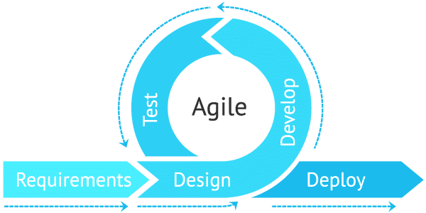

Figure 1: agile methodology

# 10. Existing Systems

The existing system for employee and employer interconnection in the employment process predominantly relies on manual and face-to-face interactions. This traditional approach involves various labor-intensive processes and often lacks efficiency and convenience. The key components of the existing system can be summarized as follows:

**1. Manual Job Posting**: Employers manually advertise job vacancies through print media or physical notices, limiting the reach and accessibility of the job opportunities. This method requires significant time and resources, resulting in delayed job postings and restricted candidate visibility.

**2. Physical Resume Submission:** Job seekers are typically required to submit physical copies of their resumes either by mail or in person. This process is cumbersome and time-consuming, as it involves handling and organizing large amounts of paperwork by employers.

**3. Face-to-Face Interviews:** The existing system heavily relies on scheduling and conducting face-to-face interviews, often requiring multiple rounds before a final hiring decision is made. This not only prolongs the recruitment process but also limits flexibility for both employers and job seekers.

**4. Limited Geographic Scope:** The traditional system keeps job opportunities limited to the local or regional area, creating barriers for employers to access talent beyond their immediate vicinity. Similarly, job seekers face challenges in exploring employment options outside their local area.

**5. Manual Candidate Screening:** Employers manually review and evaluate resumes to shortlist candidates for further consideration. This process can be subjective and time-consuming, resulting in potential inefficiencies and biases in the selection process.

Overall, the existing system lacks automation, scalability, and inclusivity. It often leads to a slow and ineffective recruitment process, restricting opportunities for both employers and job seekers. There is a clear need for an online employee and employer interconnection website to overcome these limitations and introduce a more streamlined and efficient method of connecting job seekers with potential employers.

# 11. Proposed System Design and Architecture

The proposed system design and architecture of the "Online Employee and Employer Interconnection" website research proposal aims to create an efficient and user-friendly platform that overcomes the limitations of manual and face-to-face employment processes. The system will consist of the following components:

**1. User Interface:** The user interface will be designed to provide a seamless and intuitive experience for both job seekers and employers. It will include features such as a search bar, filters, and clear navigation menus to facilitate easy access to job listings, profile management.

**2. Database:** The system will incorporate a robust database to store and manage user information, job listings, resumes, messages, and other relevant data. The database will ensure secure data storage and retrieval, allowing quick access to relevant information when needed.

**3. User Registration and Authentication:** The system will include a user registration module that allows job seekers and employers to create accounts. Authentication mechanisms will be implemented to verify user credentials and ensure secure access to the platform.

**4. Job Search and Filtering:** The system will provide a comprehensive job search feature, allowing job seekers to browse and filter job listings based on their preferences. Filters may include location, industry, job type, and experience level, enabling users to find suitable employment opportunities efficiently.

**5. Job Posting and Management:** The system will offer employers the ability to create, manage, and update job postings. Employers can provide detailed descriptions, requirements, and application instructions for interested job seekers. The system will ensure that job postings are visible to the relevant audience and easily searchable.

**6. Resume upload and Profile Management**: Job seekers will have the option to upload their resumes and other supporting documents to their profiles. The system will allow job seekers to update and manage their profiles, ensuring that employers have access to the most up-to-date information.

**9. Admin Panel:** The system will include an admin panel that allows administrators to manage and monitor the overall operation of the website. This will include user management, job listing moderation, analytics, and system maintenance tasks.

**10. Security and Privacy Measures:** The system will implement necessary security measures, including secure user authentication during login process, and access control, to ensure the privacy and protection of user data.

Overall, the proposed system design and architecture of the "Online Employee and Employer Interconnection" website research proposal aims to deliver a user-centric platform that facilitates efficient job search, communication, and hiring processes. It leverages modern technologies to streamline the employment process and help bridge the gap between job seekers and employers in a digital environment.

# 12. Functional Requirements

Define the specific functionalities of the system from the user's perspective, focusing on:

## 12.1 Employer:

* The system should allow the Employer to register, post his job vacancies with detail information.
* The system should allow the Employer to log in to the system using his username and password,
* The system should allow the Employer to update his profile, see results about his required worked after logged in to the system.

## 12.2 Employee (job seeker):

* The system should allow the Employee to register, with the detailed required information.
* The system should allow the Employee to attach his file of CV If required.
* The system should allow the Employee to login to the system using his username and password.
* The system should allow the Employee to see job lists and apply to desired job.
* The system should allow the Employee to see his statues on the system after logged in.

## 12.3 ADMIN:

* The system should allow the Admin to login to the system using his username and password and admin role.
* The system should allow the admin to see list of registered jobseekers, employers and list of job vacancies.
* The system should allow the admin to assign employers and employee based on their requirements and registered descriptions.
* The System should allow admin to manage and monitor the overall operation of the website.

# 13. Non-Functional Requirements

Define the overall quality attributes of the system, including:

Performance: Response time, system uptime, scalability, load handling capacity.

Security: Data encryption, authentication, authorization, access control, data privacy.

Usability: User interface design, ease of use, learnability, accessibility.

* + **Reliability:** System availability, error handling, fault tolerance, recovery mechanisms.
  + **Maintainability:** Ease of modifications, updates, debugging, code documentation.
  + **Compatibility**: Cross-browser compatibility, device compatibility, language support.

Define measurable metrics or benchmarks for each non-functional requirement to ensure they are met during development and testing.

# 14. Hardware & Software Tools Requirements

Identify the hardware and software required for development, testing, and deployment of the system, including:

## 14.1 The hardware tools required ARE:

Table 1: hardware tools requirement

|  |  |
| --- | --- |
| ***Hardware component*** | ***Minimum requirement*** |
| Computer or laptop |  |
| Processor Type (system type) | 64 bit/32bit operating system |
| Memory (RAM) | 2GB and above |
| Processor Speed | 3.20 GHZ and above |
| Hard Disk Space | 10GB and above |
| Mouse | Any pointing device |
| Key board | keys |

## 14.2 THE software TOOLS:

While developing the project starts from the documentation to the implementation, we use the following case tools:

Table 2: system development tools

|  |  |
| --- | --- |
| Tools | Activities |
| Notepad, Sublime text, Visual studio code | For coding PHP web language |
| CSS | For making attractive layout |
| PHP | Back end (Server-side coding) |
| HTML | Client-side coding |
| MYSQL | Back end (data base) |
| WAMP, XAMP Server | For storing patient information permanently |
| Mozilla Firefox, IE, Google Chrome, Opera | Browsers |
| MS office word 2016 | For Documentation |
| MS office PowerPoint 2016 | For Presentation |
| Adobe Photo Shop CS6 | To design back ground images |

# 

# 15. Budget

To complete our project starting down from the beginning up to the end of this project we planned the following cost list.

Table 3: Hardware budget plan

|  |  |  |  |  |  |  |
| --- | --- | --- | --- | --- | --- | --- |
| NO. | Materials | Quantity | Unit | Birr | Cent | Birr total |
| 1 | Paper | 1 | Packet | 750 | 00 | 750.00 ETB |
| 2 | Pen | 5 | PCS | 15 | 00 | 125.00 ETB |
| 3 | Flash Disk | 1 | Single | 400 | 00 | 400.00 ETB |
| 4 | Mobile Card | 10 | Single | 25 | 00 | 250.00 ETB |
| 5 | Printing | 70 | Single | 5 | 00 | 350.00 ETB |
| 6 | Binding | 3 | Single | 30 | 00 | 90.00 ETB |
| TOTAL | | | | | | **1965.00TB** |

Table 4:Software Budget Plan

|  |  |  |  |
| --- | --- | --- | --- |
| **Tools** | **Activities** | **access** | **cost** |
| Notepad, Sublime text, Visual studio code | For coding PHP web language | internet | free |
| CSS | For making attractive layout | internet | free |
| PHP | Back end (Server-side coding) | internet | free |
| HTML | Client-side coding | internet | free |
| MYSQL | Back end (data base) | internet | free |
| WAMP, XAMP Server | For storing patient information permanently | internet | free |
| Mozilla Firefox, IE, Google Chrome, Opera | Browsers | internet | free |
| MS office word 2016 | For Documentation | internet | free |
| MS office PowerPoint 2016 | For Presentation | internet | free |
| Edraw Max7.9 and Visio 2010 | To draw UML Diagram and for designs | internet | free |
| Adobe Photo Shop CS6 | To design back ground images | internet | free |

# 16. Time Schedule

This involves questions such as how much time is available to build the new system, when it can be built. The plan explains the tasks verses the time (in weeks) they will take to complete.

Table 5 : project time schedule

|  |  |  |  |  |  |  |  |
| --- | --- | --- | --- | --- | --- | --- | --- |
| Tasks | January | February | March | April | may | Jun | Task assigned to |
| Requirement  gathering |  |  |  |  |  |  | Hirut T. |
| Analysis |  |  |  |  |  |  | G/tsadik B. |
| Design |  |  |  |  |  |  | Guesh G. |
| Coding |  |  |  |  |  |  | Haftay D. |
| Testing |  |  |  |  |  |  | Hayat T. |
| Implement |  |  |  |  |  |  | Lidya |
| presentation | 1 |  |  |  |  |  | All me |

# 17. Conclusion and Recommendation

## 17.1 Conclusion:

The "Online Employee and Employer Interconnection" website research proposal presents a compelling and innovative solution to overcome the limitations of manual and face-to-face employment processes. By developing a user-centric online platform, the proposal aims to streamline the job search and hiring process, enhance efficiency, and improve access to employment opportunities.

The significance of this research proposal lies in its potential to transform the employment landscape, providing a centralized platform that connects job seekers with suitable opportunities and enables employers to efficiently identify and select qualified candidates. The proposed online platform offers cost-effective solutions, expands job market reach, and fosters economic growth by contributing to reduced unemployment rates and increased labor market efficiency.

## 17.2 Recommendation:

Based on the research proposal for the "Online Employee and Employer Interconnection" website, it is recommended to proceed with the development and implementation of the proposed online platform. This project has the potential to revolutionize the way job seekers and employers connect, eliminating the limitations of traditional employment processes.

To ensure the success of the project, it is recommended to focus on user experience, ensuring a user-friendly and intuitive interface. The platform should prioritize data security and privacy to build user trust.

Additionally, it is recommended to conduct user research and gather feedback during the development and implementation phases. This feedback will provide valuable insights for further enhancements and customization of the platform to meet the evolving needs of job seekers and employers.

# 18. References:

Here List all references used in the SRS proposal, including research papers, articles, books, websites, and other sources of information.

* A THESIS SUBMITTED IN PARTIAL FULFILLMENT OF THE REQUIREMENTS FOR THE BACHELOR OF EDUCATION (BED) IN INFORMATION TECHNOLOGY TOPIC: DESIGN AND IMPLEMENTATION OF ONLINE JOB PORTAL
* Chat Gpt AI, Bing AI, Bard AI
* [**https://www.perforce.com/blog/alm/how-write-software-requirements-specification-srs-document**](https://www.perforce.com/blog/alm/how-write-software-requirements-specification-srs-document)
* [**https://www.geeksforgeeks.org/software-requirement-specification-srs-format/**](https://www.geeksforgeeks.org/software-requirement-specification-srs-format/)
* [**https://slcc.pressbooks.pub/technicalwritingatslcc/chapter/software-requirements-specification-srs/**](https://slcc.pressbooks.pub/technicalwritingatslcc/chapter/software-requirements-specification-srs/)

# 19. Annex

Here list of figures that describe the manual and face to face employee and employer interconnection system we found during requirement gathering by interview.



Figure 2: The existing systems agency advertisement method

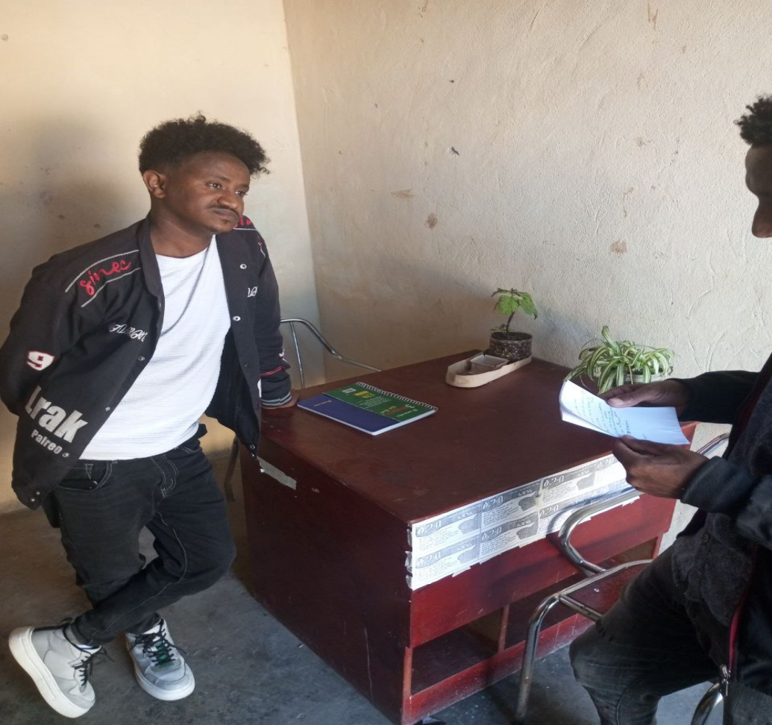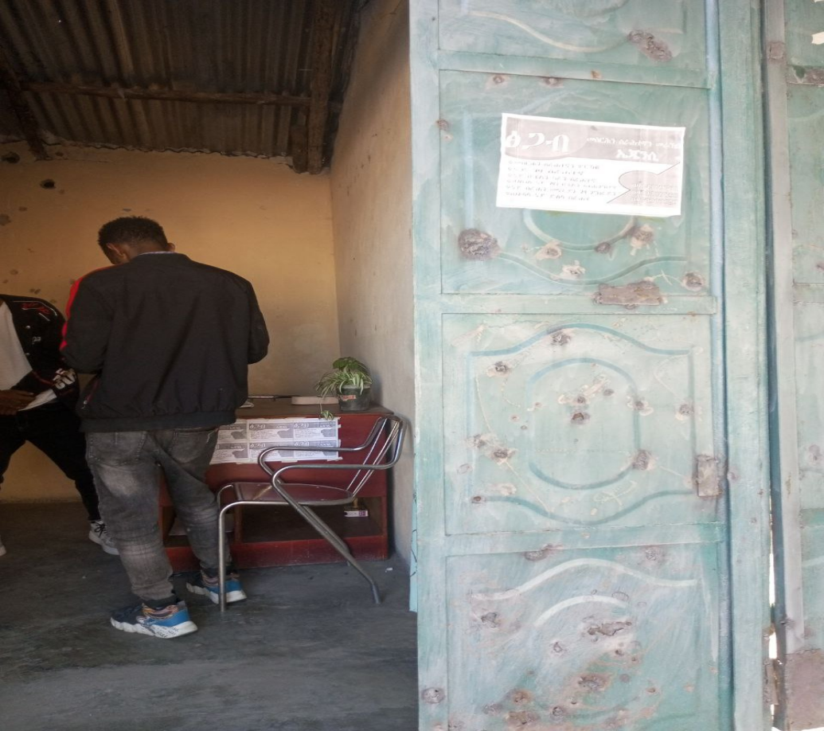

Figure 3: The Interview in the employment agency during requirement gathering



Figure 4 : Data storing method in the existing system



Figure 5 : The Contract Negotiation paper in the existing system

## Git: creating a repo, committing, pulling and pushing, pull request, merge conflict fixing

Here's a guide covering Git fundamentals, including repo creation, commits, pulling/pushing, pull requests, and merge conflict resolution:

**Before You Start**

* **Install Git:** Download and install Git for your operating system: <https://git-scm.com/downloads>
* **Create a GitHub Account (Optional):** If you want to work with a remote repository on GitHub, you'll need a free account: <https://github.com>

**Key Concepts**

* **Repository:** A Git repository (repo) is a project directory that tracks file changes over time.
* **Commits:** A commit is a snapshot of your project at a specific point.
* **Branch:** A branch is an independent line of development within a repository. The default branch is usually called main or master.
* **Remote Repository:** A remote repository is a version of your project hosted on a server (e.g., GitHub, GitLab, Bitbucket).
* **Pull:** Fetching changes from a remote repository and merging them into your local repository.
* **Push:** Sending your local commits to a remote repository.
* **Pull Request:** A way to propose changes from your branch to be merged into another branch on a remote repository.
* **Merge Conflict:** When two changes to the same code area conflict, making Git unable to automatically merge them.

**Steps**

1. **Creating a Repository**
   * **Local Repository:**
     1. Open your terminal.
     2. Navigate to your desired project directory: cd path/to/project
     3. Initialize: git init
   * **Remote Repository on GitHub:**
     1. Create a new repository on GitHub.
     2. Follow the instructions provided by GitHub to connect it to your local repository.
2. **Committing Changes**
   * Make changes to your files.
   * Stage your changes: git add <file1> <file2> ... (or git add . to stage all modified files)
   * Commit with a clear message: git commit -m "Description of your changes"
3. **Pulling and Pushing**
   * **Pull:** Download changes from the remote repository: git pull origin <branch_name>
   * **Push:** Upload your local commits to the remote repository: git push origin <branch_name>
4. **Pull Requests**
   * Push your changes to a branch on the remote repository.
   * On GitHub (or similar platforms), create a pull request to propose merging your branch into the target branch.
   * Code reviews and discussions can happen on the pull request.
   * Once approved, the pull request can be merged.
5. **Merge Conflict Resolution**
   * **Identify the conflict:** Git will mark conflicted areas in your file. Look for <<<<<<<, =======, and >>>>>>> markers.
   * **Resolve the conflict:** Manually edit the file to decide which changes to keep, or a combination of both.
   * **Stage and commit:**
     1. Stage the resolved file: git add <file>
     2. Commit the resolution: git commit -m "Resolved merge conflict"

**Tips**

* **Use descriptive commit messages.**
* **Create branches for new features** to isolate your work.
* **Review pull requests carefully** before merging.

**Additional Resources**

* **Official Git Documentation:** <https://git-scm.com/doc>
* **Git Tutorial from Atlassian:** <https://www.atlassian.com/git/tutorials>
* **Interactive Git Cheat Sheet:** <https://ndpsoftware.com/git-cheatsheet.html>

Let me know if you'd like specific examples or have questions about more advanced scenarios!